WEBD 1000 Media Queries

**Website Development**

# Instructions

**You will complete the following steps in class and post the file(s) that you are asked to produce to the Brightspace dropbox for today’s in-class activity. If you need help with any step, ask the instructor.**

1. In the BrightSpace dropbox for today’s activity, you have been provided with a ZIP file containing some file resources for a web page:
   1. An HTML page called *lawncare.html*
   2. CSS files called *styles.css and layout-styles.css*.
   3. Images called *grass_seamless_pattern.jpg*, *mowercycle.jpeg*, and *weeding_success.jpeg.*
2. This site is essentially the AFTER state of our Exercise 8 where we made a CSS Grid for Acme lawncare, but we will consider it the BEFORE of this Exercise.
3. Copy the site to an Exercise 12 folder in your preferred folder location for this class.
4. Open the site files in NotePad++ (or the editor of your choice):
   1. Preview the *lawncare.html* file in a browser. Your page should look like the BEFORE image on the following page.
5. You will mostly modify the *layout_styles.css* file:
   1. However, add a good <meta> viewport line to the HTML <head> section.
   2. You will make the following additions to the new *layout_styles.css* page:
      1. Add a comment marking yourself as the author and with today’s date (in the CSS file).
      2. Move styles in the layout section that should apply to all device sizes to the top of the page (e.g. centering text, floating images, etc.)
      3. Add new media queries as shown in the video to the CSS file for phone, tablet, & desktop device widths.
      4. Move all the current grid code into the **Tablet query** but set the columns to be 2 of **equal** size.
      5. In the **Desktop query**, set the grid columns to be the original 40% -> 60% arrangement, still with 2 columns.
      6. In the **Phone query**, make the main header font a bit smaller so that the heading does not take up so much space and set a margin between all articles as we will have no grid and no column or row spacing.
      7. Perhaps give the second heading different background colours in every media query just for testing purposes as I have done in my after pictures.
   3. **See the AFTER examples on the next page(S) for an idea of what the Webpage should now look like. NOTE: Use the Google DevTools Device Emulator to check out your layout on different devices.**
6. As an added challenge:
   1. try adding a horizontal menu to the site in tablet/desktop layouts. The links can be dummy links (i.e. href=”#”) for now. HINT: use the display: block, floating, and fluid width technique from our last assignment (Slate & Pencil Tutoring).
   2. Hide the links on the phone layout and show a navicon instead as done at the end of the next Video. Try to make the mobile menu only show up when hovering over the navicon or menu.
7. Once the above Step is completed, validate the ***layout_styles.css*** file using the W3C CSS validation website. Take a screenshot showing successful validation.
8. Post a ZIP file containing both **the whole website** plus **screenshot of successful validation** to the Brightspace Dropbox for the twelfth in-class exercise in order to obtain credit for completing it.
9. That’s it.

# Highly Recommended

**There is no need to submit the results of this part of the activity and it will not be graded. However, it will be excellent practice for the upcoming assignment. If you need help with any step, ask the instructor.**

1. Complete the Tutorial 5 – Session 1 practice steps from the Textbook. The practice tutorial steps are in light brown or beige boxes within the chapters of the textbook. In this case the tutorial steps begin on page **HTML370** (Section 5-3c) and conclude on page **HTML389** (Section 5-7) for this Session.
2. Once the above Step is completed, validate the following file using the W3C CSS validation website:
   1. *tf_styles1.css*

# Before:

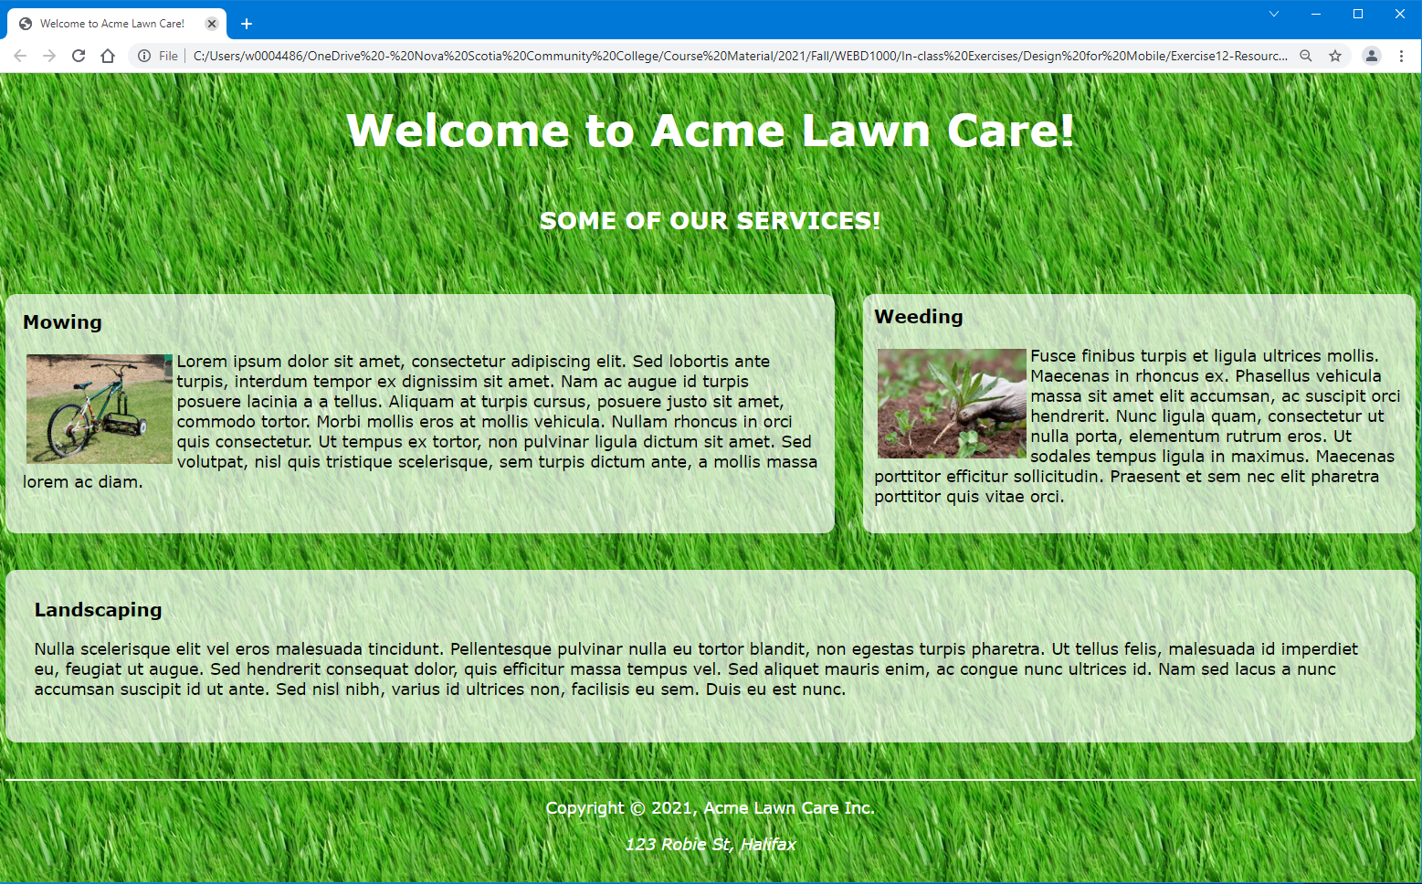

# After (Tablet Landscape Layout):

# After (Desktop Layout – same as before except testing H2):

# After (Phone Landscape – both top of page and bottom):

|  |  |
| --- | --- |
|  |  |